**Preparation of Camera-Ready Papers for PARITANTRA**

Author1a†, Author2a§¶, and Author3b♣

a *Affiliation of the Authors (e.g. Indian Institute of Technology, Kharagpur-721 032, India)*

b *Affiliation of the Authors (e.g. Indian Institute of Science, Banglore, India )*

(Received on XX YYYY 2021, received in revised form XX Month 2021, accepted XX Month 2021)

These instructions give you guidelines for preparing papers for the *JSSE Proceedings* using Microsoft *Word* 6.0 or later. Use this document as a template. Authors are requested not to change font type or font size in any section. Abstract of the paper has to be given in this section. Define all symbols used in the abstract. Do not cite references in the abstract.

*Index Terms*--About four, alphabetical order, key words or phrases, separated by commas.

NOMENCLATURE

*Iyy*  Moment of inertia of vehicle about yaw axis

*mT* Total mass of vehicle

*m0*  Reduced mass of vehicle

U0 Forward velocity of vehicle

*Vw* Wind velocity

*V ,VR*  Absolute and relative velocities respectively

Tc Control Thrust

*Lα* Aero dynamical load per unit angle of attack

*lc* Distance mass centre of vehicle to engine swivel point

lα Distance from mass centre of vehicle to centre of pressure

α Angle of attack

αw Wind angle of attack

θ Attitude angle

δFT Thrust deflection angle

 Control moment coefficient

 Aerodynamic moment coefficient[1]*

γ Perturbation flight path angle

g Gravity acceleration

 Total perturbation force acting parallel to vehicle

body axis ZB

 Total perturbation moment about pitch axis of vehicle

 Lateral drift rate.

# **Introduction**

This document is a template for Microsoft *Word* versions 6.0 or later.

Page limit is 10 pages for Full papers and 6 pages for Short papers. Do not adjust the font sizes or line spacing specified in this document to squeeze more text into a limited number of pages.

# **Procedure for Paper Submission**

### Paper Version

When you submit your final version, print it in two-column format, including figures and tables. To insert images in *Word,* use Insert | Picture | From File. **Also submit, on separate sheets of paper, enlarged versions of the tables and figures that appear in your document.** These are back-up images, in case we cannot read your electronic image files (see below). Also send a sheet of paper with author contact information--including telephone, fax, and e-mail--so that we can contact you if there is any problem with your paper.

### Electronic Version

You must also send your final manuscript by e-mail or on a disk, which we will use to prepare your paper for publication. Write the names of the authors on the disk labels.

All tables and figures will be processed as images. **However, we cannot extract the tables and figures embedded in your document.** Thus, electronic versions of the tables and figures should be on disk or disks, separate from your document file, in TIFF or JPEG format.

Use a separate file for each TIFF image. High-contrast line figures and tables should be prepared with 600 dpi resolution and saved with no compression, 1 bit per pixel (monochrome), with file names of the form "1fig600.tif" or "2tab600.tif." To obtain a 3.45 inch figure (one column width) at 600 dpi, the figure requires a horizontal size of 2070 pixels. Typical file sizes will be on the order of 0.5 MB. Photographs, color figures, and grayscale figures should be prepared with 220 dpi resolution and saved with no compression, 8 bits per pixel (256 color or grayscale), with a file name of the form "3fig220.tif." To obtain a 3.45 inch figure (one column width) at 220 dpi, the figure should have a horizontal size of 759 pixels.

If you are not able to prepare your figures in TIFF, you may instead submit non-color figures in PostScript (PS) or Encapsulated PostScript (EPS) formats. File names should be of the form "4fig.ps" or "5fig.eps."

Some useful image converters are Adobe *Photoshop,* Corel *Draw,* and Microsoft *Photo Editor,* an application that is part of Microsoft *Office 97*. Using *Word,* you may create a table, copy it to the clipboard, and paste it directly into *Photoshop,* for example. (For some image converters, you may need to copy and paste tables into Microsoft *Paint* to create an intermediate bitmap image.) Then you may crop the table, resize it to 3.45 inch width and 600 dpi resolution, and save the image in TIFF using no compression and 1 bit (see caption for Table I). Many image converters allow you to resize but do not permit adjustment of resolution.

Most graphing programs allow you to save graphs in TIFF; however, you often have no control over compression or number of bits per pixel. You should open these image files in a program such as Microsoft *Photo Editor* and re-save them using no compression, either 1 or 8 bits, and either 600 or 220 dpi resolution (File | Properties; Image | Resize).

Microsoft *Excel* allows you to save spreadsheet charts in Graphics Interchange Format (GIF). To get good resolution, make the *Excel* charts *very* large. Then use the "Save as HTML" feature (see http://support.microsoft.com/support/ kb/articles/q158/0/79.asp). You would then convert from GIF to TIFF using Microsoft *Photo Editor,* for example.

No matter how you convert your images, it is a good idea to print the TIFF files to make sure nothing was lost in the conversion. If you have a scanner, you may get quicker results by printing your tables and figures, scanning them, and then saving them to a file. Use 600 or 220 dpi resolution, 1 or 8 bits, and no compression.

# **MATH**

Use either the Microsoft Equation Editor or the *MathType* add-on for all math objects in your paper (Insert | Object | Create New | Microsoft Equation *or* MathType Equation). "Float over text" should *not* be selected. We recommend defining a keyboard shortcut (e.g., ALT+E) to open the equation editor (Tools | Customize | Commands | Keyboard | Insert InsertEquation).

A math object is any equation or fragment containing mathematical symbols (including Greek characters, superscripts and subscripts) that appears either in-line (in the flow of normal text) or as a display equation (in its own space between lines of text).

In particular, you should avoid using *Word* fonts or symbols for in-line single variables with superscripts or subscripts. Use italics for emphasis; do not underline. Turn off "smart quotes" (Tools | AutoCorrect | AutoFormat tabs). Turn off automatic hyphenation (Tools | Language | Hyphenation).

Preparing your math, both in-line and display, with the Equation Editor or *MathType* allows us to automatically convert most of the math in your paper to their in-house math format while allowing you to format math for the hard copy of your paper. **Do not worry about the extra space created around your math objects; it will not appear in the published version of your paper.** The *MathType* add-on for *Word* is a commercial product. If you have *MathType,* use it for as much of your math as possible. If not, use the Microsoft equation editor, which comes as part of *Word.*

# **Units**

Use either SI (MKS) or CGS as primary units. (SI units are strongly encouraged.) English units may be used as secondary units (in parentheses). An exception is when English units are used as identifiers in trade, such as "3 in disk drive." Avoid combining SI and CGS units, such as current in amperes and magnetic field in oersteds. This often leads to confusion because equations do not balance dimensionally. If you must use mixed units, clearly state the units for each quantity in an equation.

The SI unit for magnetic field strength *H* is A/m. However, if you wish to use units of T, either refer to magnetic flux density *B* or magnetic field strength symbolized as .

# **Helpful Hints**

## Figures and Tables

Large figures and tables may span both columns. Place figure captions below the figures; place table titles above the tables. **Do not put captions in "text boxes" linked to the figures. Do not put borders around your figures.**

Use the abbreviation "Fig." even at the beginning of a sentence. Do not abbreviate "Table." Tables are numbered with Roman numerals. Remember to include TIFF files of figures and tables with your final paper submission (see Section II.B.2).

TABLE I

Units for Magnetic Properties

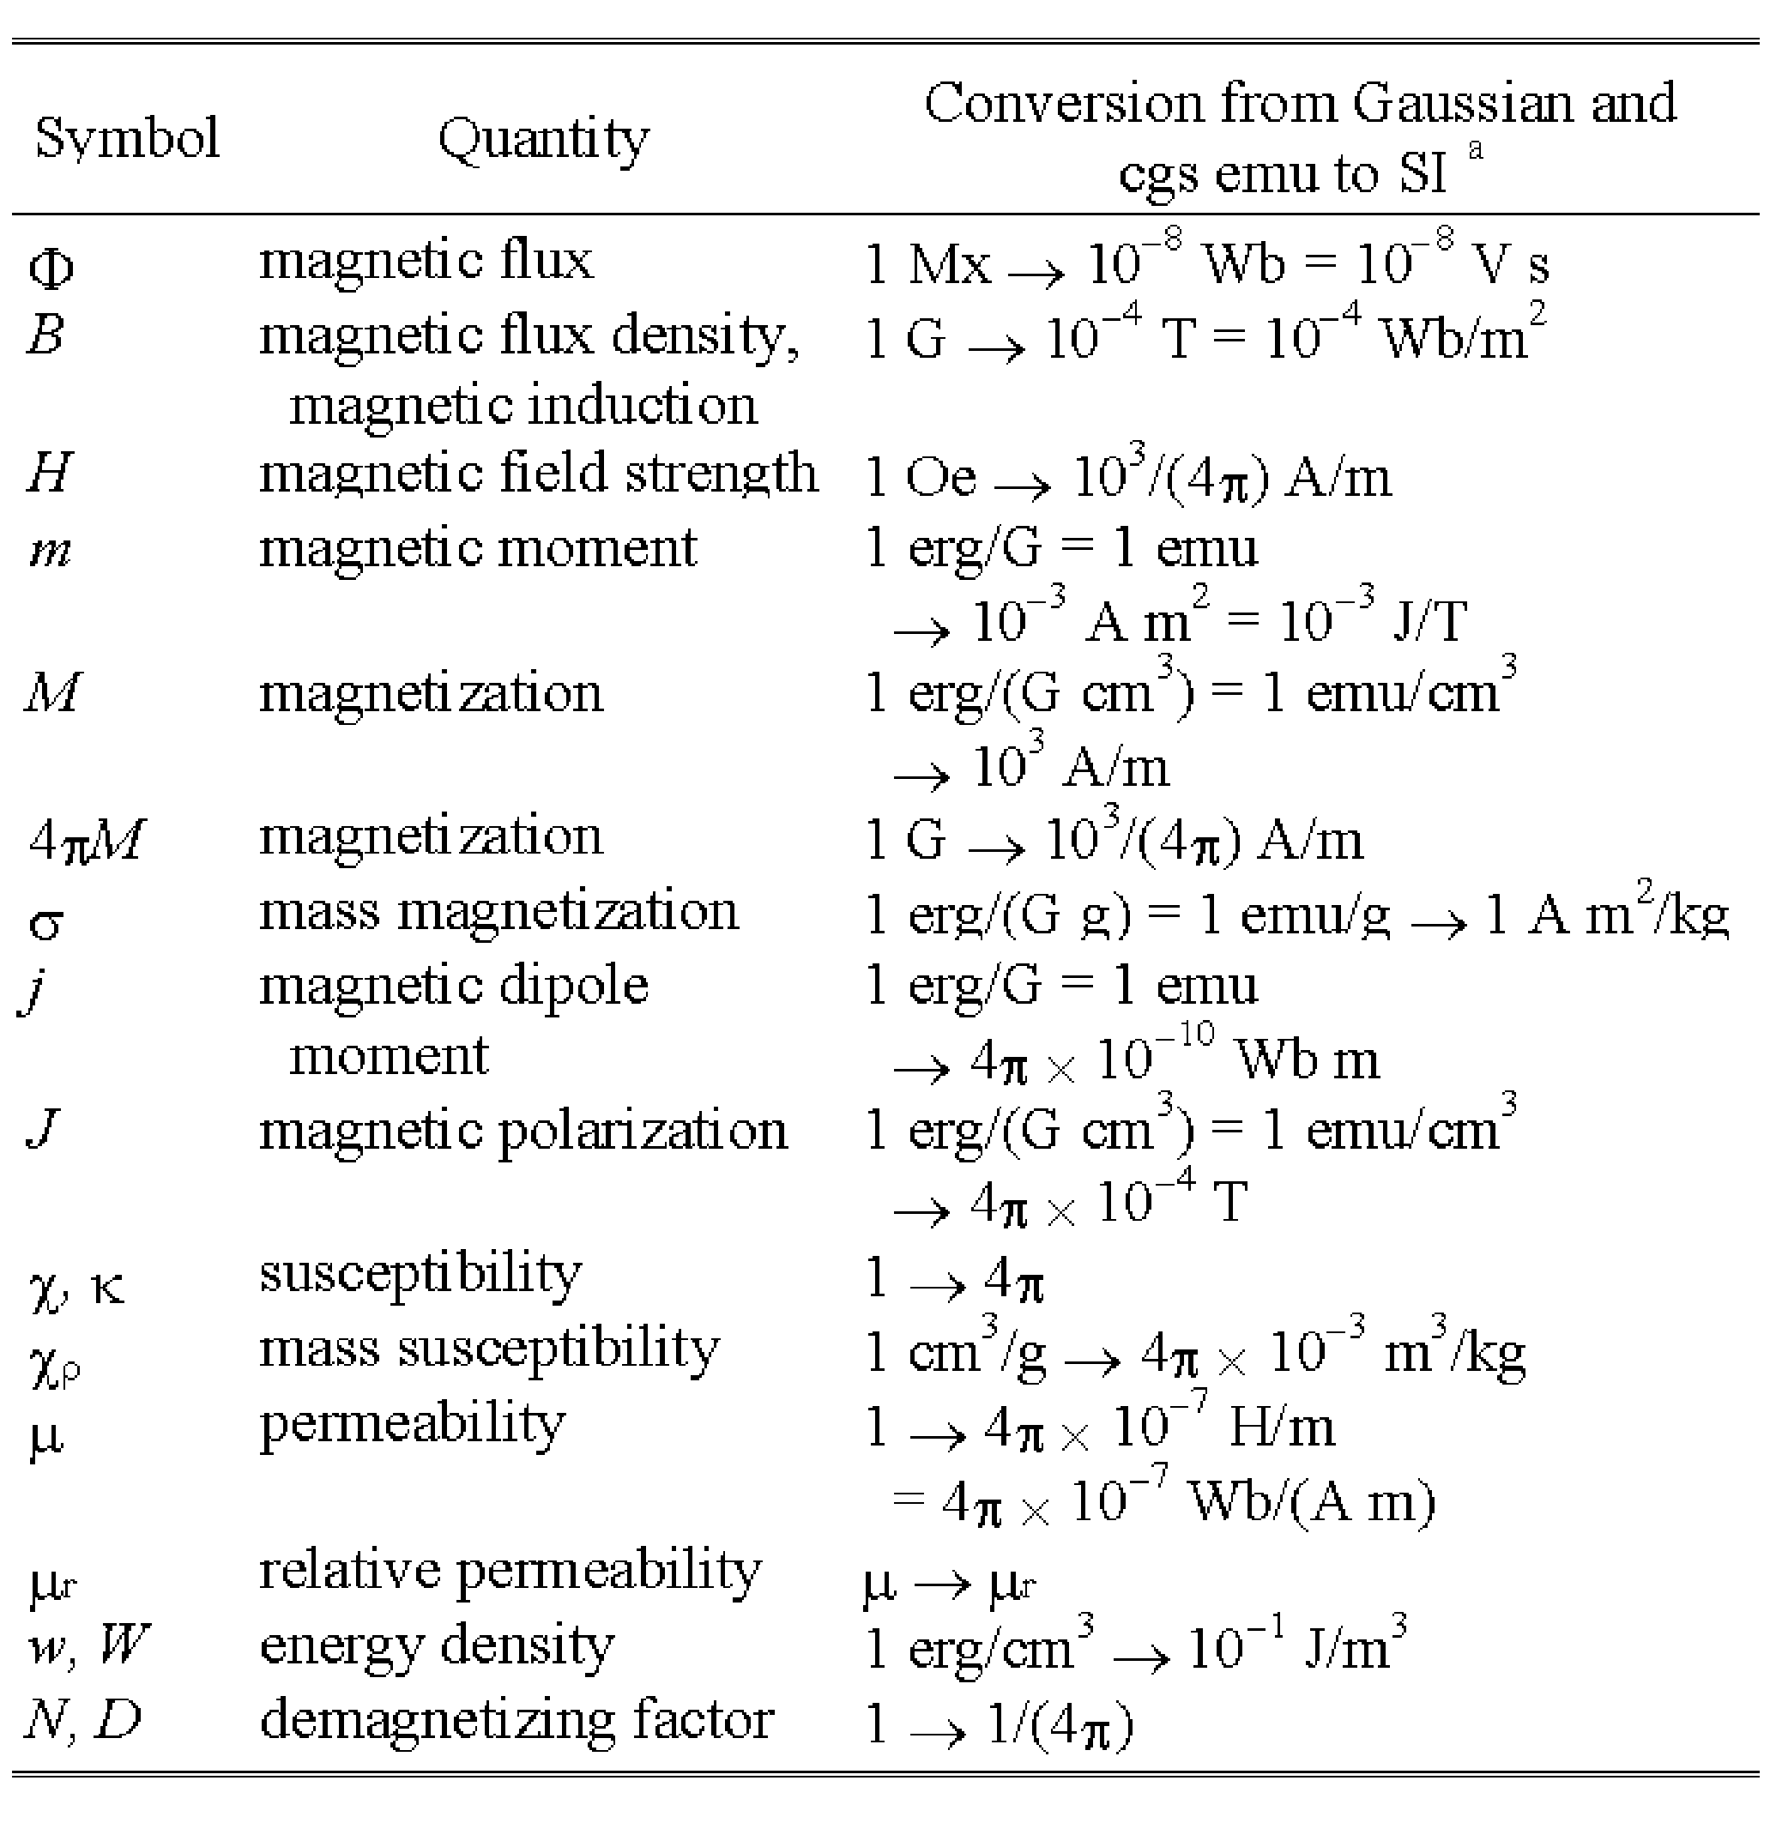

No vertical lines in table. Statements that serve as captions for the entire table do not need footnote letters. This table was originally created in *Word* using 20 point font (to occupy the maximum width of a page), selected, and copied to the *Windows* Clipboard. In Adobe *Photoshop,* a new file was opened in "Bitmap" mode and the contents of the Clipboard was pasted. The table image was then cropped and resized to 3.45 inch width (while maintaining proportions), with a new resolution of 600 dpi. It was then saved as file 1TAB600.TIF with no compression. The image file was then inserted into this *Word* document as an image.

aGaussian units are the same as cgs emu for magnetostatics; Mx = maxwell, G = gauss, Oe = oersted; Wb = weber, V = volt, s = second, T = tesla, m = meter, A = ampere, J = joule, kg = kilogram, H = henry.

.

Figure axis labels are often a source of confusion. Use words rather than symbols. As an example, write the quantity "Magnetization," or "Magnetization, *M*," not just "*M*." Put units in parentheses. Do not label axes only with units. As in Fig. 1, for example, write "Magnetization (A/m)" or "Magnetization (Am)," not just "A/m." Do not label axes with a ratio of quantities and units. For example, write "Temperature (K)," not "Temperature/K."

Multipliers can be especially confusing. Write "Magnetization (kA/m)" or "Magnetization (A/m)." Do not write "Magnetization (A/m)" because the reader would not know whether the top axis label in Fig. 1 meant 16000 A/m or 0.016 A/m. Figure labels should be legible, approximately 8 to 10 point type.

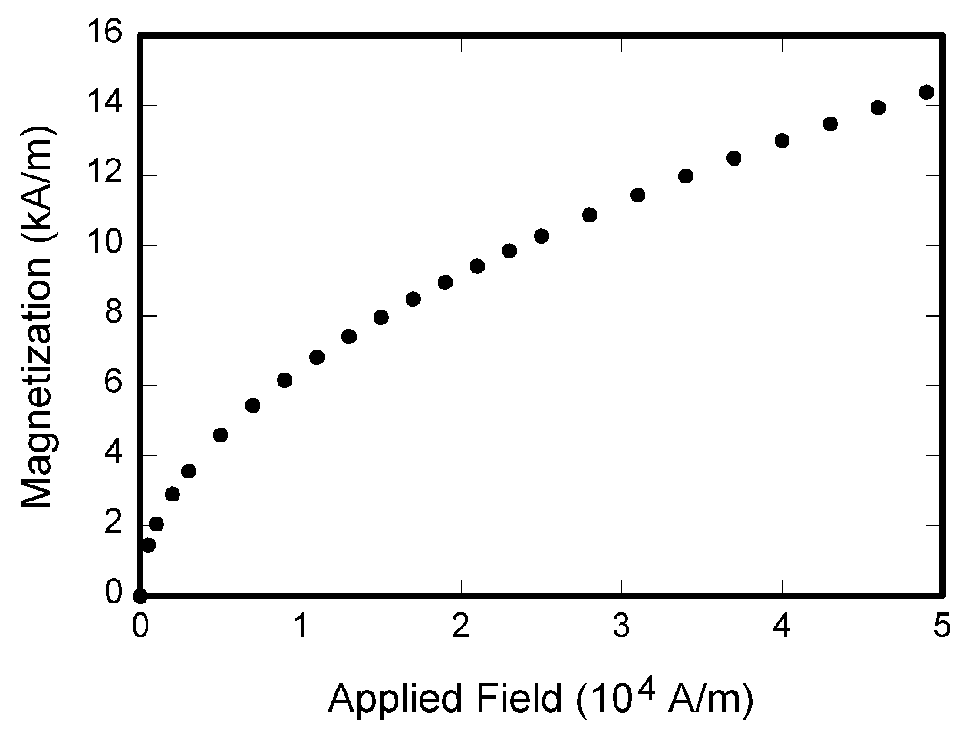

Fig. 1. Magnetization as a function of applied field. Note that "Fig." is abbreviated. There is a period after the figure number, followed by two spaces. It is good practice to explain the significance of the figure in the caption. This figure was originally created in a graphics program, *SigmaPlot.* The graph was selected and exported as type TIFF at 600 dpi monochrome. It was then opened in *Photoshop,* cropped to remove the white border, converted from "Indexed Color" to "Grayscale" and then to "Bitmap," resized to 3.45 inch width (while maintaining proportions), and saved as file 1FIG600.TIF with no compression. The image file was then inserted into this *Word* document as an image.

## References

Number citations consecutively in square brackets [1]. The sentence punctuation follows the brackets [2]. Multiple references [2], [3] are each numbered with separate brackets [1]-[3]. In sentences, refer simply to the reference number, as in [3]. Do not use "Ref. [3]" or "reference [3]" except at the beginning of a sentence: "Reference [3] shows ...". Type the reference list at the end of the paper using the "References" style.

Number footnotes separately in superscripts (Insert | Footnote).[2] Place the actual footnote at the bottom of the column in which it is cited; do not put footnotes in the reference list (endnotes). Use letters for table footnotes (see Table I).

.

Give all authors' names; do not use "et al." unless there are six authors or more. Use a space after authors' initials. Papers that have not been published should be cited as "unpublished" [4]. Papers that have been submitted or accepted for publication should be cited as "submitted for publication" [5]. Please give affiliations and addresses for personal communications [6].

Capitalize only the first word in a paper title, except for proper nouns and element symbols. If you are short of space, you may omit paper titles. However, paper titles are helpful to your readers and are strongly recommended. For papers published in translation journals, please give the English citation first, followed by the original foreign-language citation [7].

## Abbreviations and Acronyms

Define abbreviations and acronyms the first time they are used in the text, even after they have already been defined in the abstract. Abbreviations such as IEEE, SI, ac, and dc do not have to be defined. Abbreviations that incorporate periods should not have spaces: write "C.N.R.S.," not "C. N. R. S." Do not use abbreviations in the title unless they are unavoidable (for example, IEEE in the title of this article).

## Equations

Number equations consecutively with equation numbers in parentheses flush with the right margin, as in (1). To make your equations more compact, you may use the solidus ( / ), the exp function, or appropriate exponents. Use parentheses to avoid ambiguities in denominators. Punctuate equations when they are part of a sentence, as in



Be sure that the symbols in your equation have been defined before the equation appears or immediately following. Refer to "(1)," not "Eq. (1)" or "equation (1)," except at the beginning of a sentence: "Equation (1) is ..."

## Other Recommendations

Use one space after periods and colons. Hyphenate complex modifiers: "zero-field-cooled magnetization." Avoid dangling participles, such as, "Using (1), the potential was calculated." [Did the potential use (1)?] Write instead, "The potential was calculated by using (1)," or "Using (1), we calculated the potential."

Use a zero before decimal points: "0.25," not ".25." Use "cm," not "cc." Indicate sample dimensions as "0.1 cm  0.2 cm," not "0.10.2 cm." Do not mix complete spellings and abbreviations of units: use "Wb/m" or "webers per square meter," not "webers/m." When expressing a range of values, write "7 to 9," not "7-9" or “7~9,” except for references [1]-[3].

A parenthetical statement at the end of a sentence is punctuated outside of the closing parenthesis (like this). (A parenthetical sentence is punctuated within the parentheses.) In American English, periods and commas are within quotation marks, like "this period." Other punctuation is "outside"!

If you wish, you may write in the first person singular or plural and use the active voice ("I observed that ..." or "We observed that ..." rather than "It was observed that ..."). If your native language is not English, please get a native English-speaking colleague to proofread your paper.

# **Some Common Mistakes**

The word "data" is plural, not singular. The subscript for the permeability of vacuum  is zero, not a lowercase letter "o." Use the word "micrometer" instead of "micron." A graph within a graph is an "inset," not an "insert." The word "alternatively" is preferred to the word "alternately" (unless you really mean something that alternates). Do not use the word "essentially" to mean "approximately" or "effectively." Be aware of the different meanings of the homophones "affect" and "effect," "complement" and "compliment," "discreet" and "discrete," "principal" and "principle." Do not confuse "imply" and "infer."

The prefix "non" is not a word; it should be joined to the word it modifies, usually without a hyphen. There is no period after the "et" in the Latin abbreviation "et al." The abbreviation "i.e." means "that is," and the abbreviation "e.g." means "for example." An excellent style manual and source of information for science writers is [8].

# **Appendix**

Appendices, if needed, appear before the acknowledgment.

# **Acknowledgment**

The preferred spelling of the word "acknowledgment" is without an "e" after the "g." Use the singular heading even if you have many acknowledgments. Avoid the expression, "One of us (S.B.A.) thanks ..." Instead, write "S.B.A. thanks ..." Put sponsor acknowledgments in the unnumbered footnote on the first page.

# **References**

1. G. Eason, B. Noble, and I. N. Sneddon, "On certain integrals of Lipschitz-Hankel type involving products of Bessel functions*," Phil. Trans. Roy. Soc.* London, vol. A247, pp. 529-551, Apr. 1955.
2. J. Clerk Maxwell, *A Treatise on Electricity and Magnetism,* 3rd ed., vol. 2. Oxford: Clarendon, 1892, pp. 68-73.
3. I. S. Jacobs and C. P. Bean, "Fine particles, thin films and exchange anisotropy," in *Magnetism,* vol. III, G. T. Rado and H. Suhl, Eds. New York: Academic, 1963, pp. 271-350.
4. K. Elissa, "Title of paper," unpublished.
5. R. Nicole, "Title of paper with only first word capitalized," *J. Name Stand. Abbrev.,* submitted for publication.
6. C. J. Kaufman, Rocky Mountain Research Laboratories, Boulder, CO, personal communication, 1992.
7. Y. Yorozu, M. Hirano, K. Oka, and Y. Tagawa, "Electron spectroscopy studies on magneto-optical media and plastic substrate interface," *IEEE Transl. J. Magn. Jpn.,* vol. 2, pp. 740-741, August 1987 [*Dig. 9th Annual Conf. Magn. Jpn.,* p. 301, 1982].
8. M. Young, *The Technical Writer's Handbook.* Mill Valley, CA: Univer

1. ¶ *Corresponding Author:* Tel: +91 XXXXX Fax: +91 XXXXXX

   † Masters Student with Department of Aerospace Engineering

   § Assistant Professor with Department of Aerospace Engineering ♣ Professor with Department of Electrical Engineering

   *E-mail addresses:* xyz@ae.iitkgp.ernet.in (Author 1), pqr@ae.iitkgp.ernet.in (Author 2), ghi@ae.iisc.ernet.in (Author 3)

   ISSN 0972-5032 / © 2021 SSI All rights reserved.
2. It is recommended that footnotes be avoided (except for the unnumbered footnote with the author affiliation on the first page). Instead, try to integrate the footnote information into the text.